**City Council Turnout Analysis**

We examine the change in voter turnout over the various CC election years (2011, 2013, 2015, 2017, and 2019). We are answering an essential question: **How has voter turnout by precinct changed across city council election year**?

**Part 1: “Volatility” of Voter Turnout**

To begin, we examine the volatility of voter turnout in each election year. Here we are examining the voter turnout of each specific precinct, that is, the percentage of registered voters in a specific precinct who cast a ballot in the election.

First finding the mean:

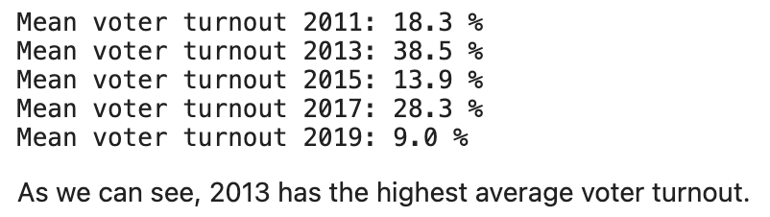

Then the median:

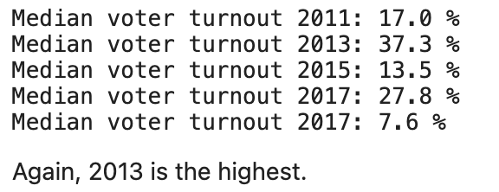

Finding that 2013 and 2017 had the highest voter turnout rates across all precincts due to the fact that they coincided with the Mayoral Elections of those same years.

Next, we determine the “Top 20 Precincts” which have the most volatile voter turnout. That is, have the greatest average change in voter turnout in that specific precinct based on election year. Listed in descending order:

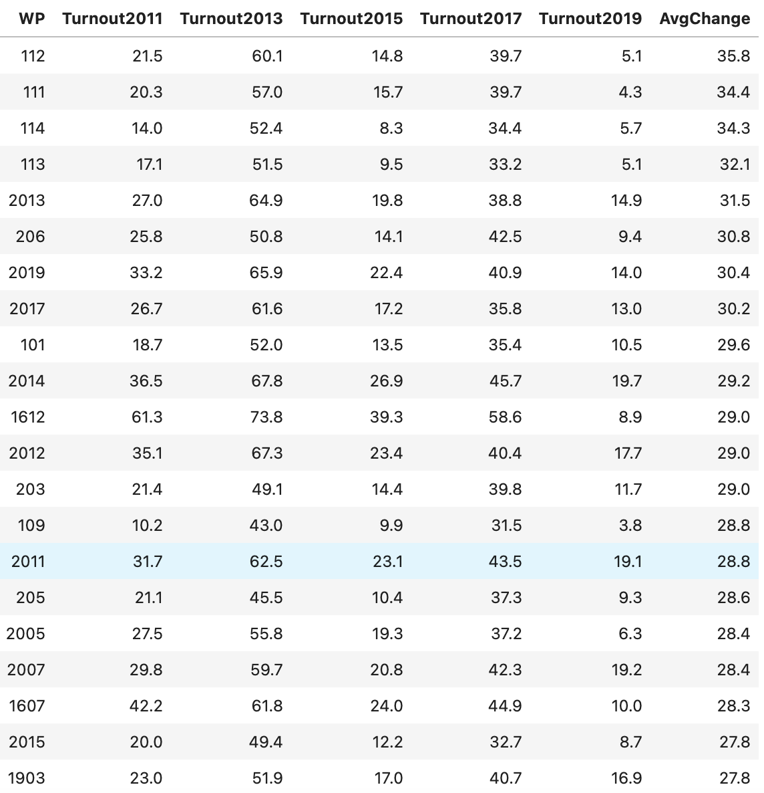

Simply from looking at the raw data, we can see that Ward 1 (East Boston), sees a lot of volatility.

Visualizing this change across elections on a bar chart, we have:

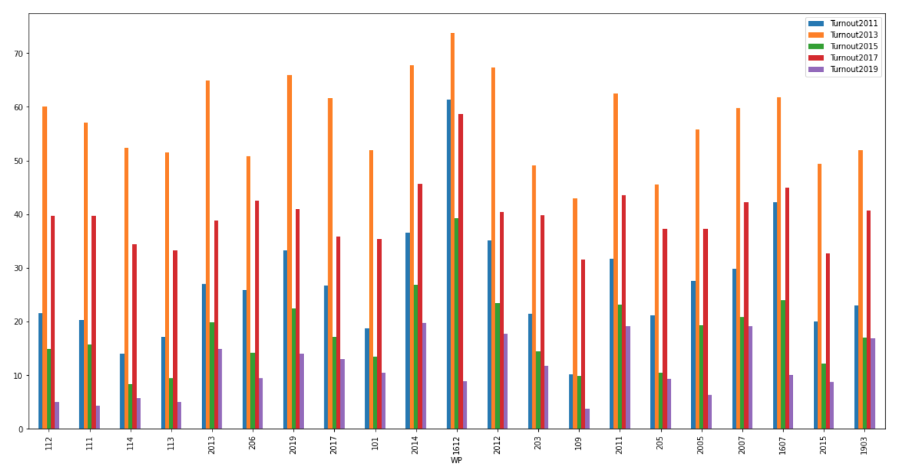

We can clearly see that voter turnout is highly volatile across each of these precincts.

Listing the demographic breakdown of each of these precincts:

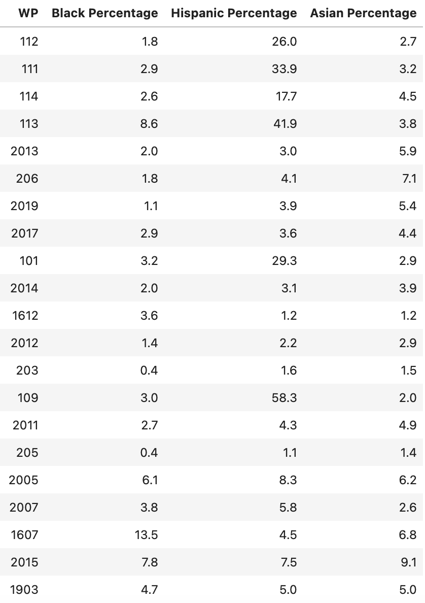

Now, we do a demographic breakdown of each of these precincts, finding the following:

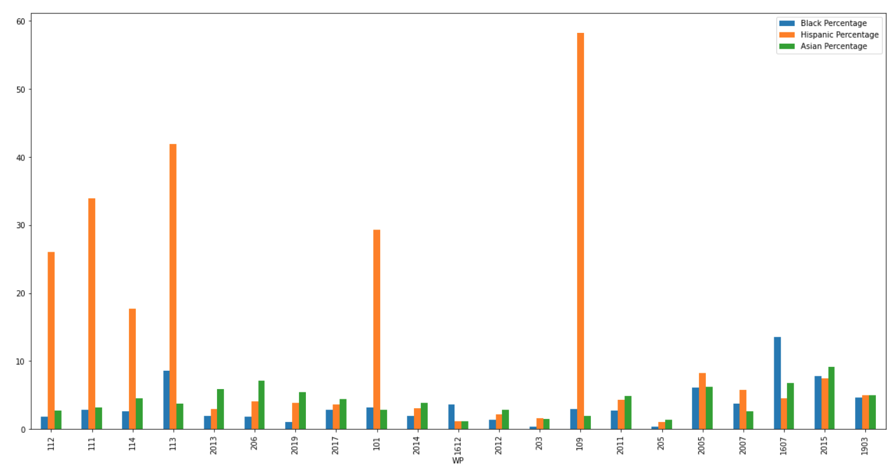

And viewing these precincts on a Boston map, we again see the concentration of precincts in East Boston as well as a concentration in West Roxbury:

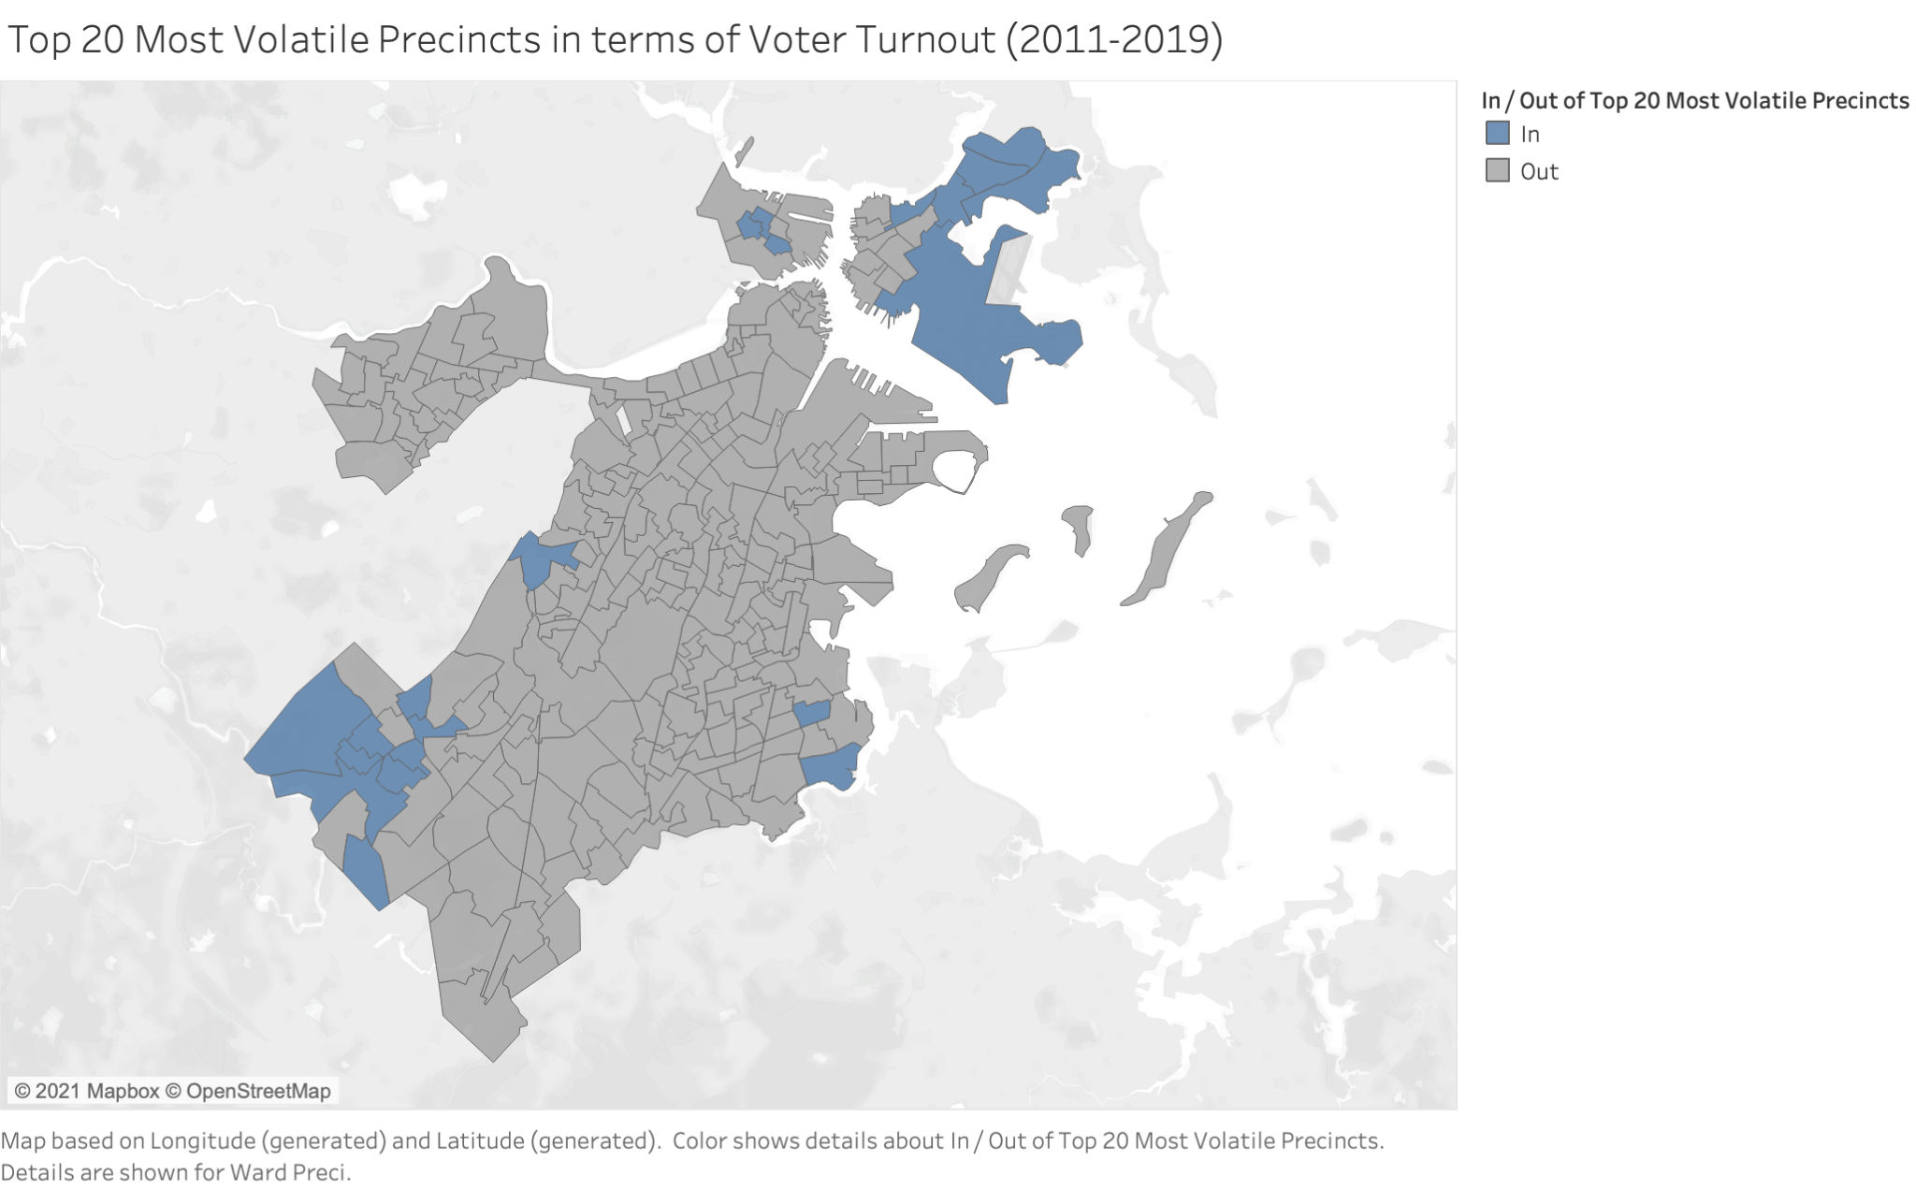

Additionally, we can use a heat map to visualize which districts experience the most volatility across city council elections:

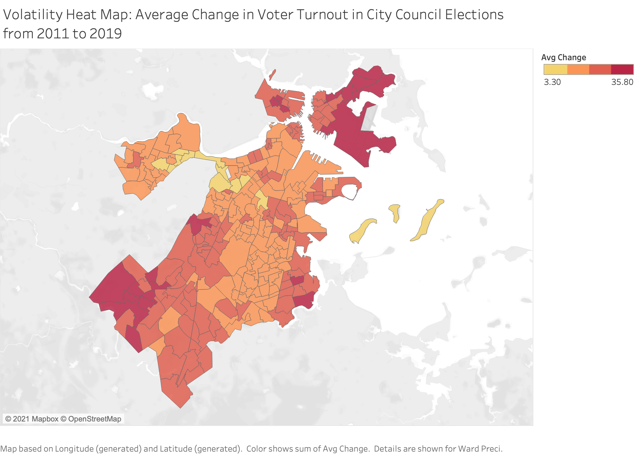

**Part 2: Changes in Share of Voter Turnout**

We now analyze which precincts experienced the greatest average change in *share of voter turnout* over time. That is, we are analyzing what percentage of the total votes cast for this particular election is from each precinct, and then analyzing the precincts which experienced the greatest change.

**Metric**: For each precinct, we calculate the percent share of votes: [Number of Ballots Cast in Precinct X]/[Total Ballots Cast in CC Election YYYY] * 100.

First, we find the top 20 precincts with the greatest average change in share of voters across each election. Note that these top 20 could be experiencing either significant negative or positive change.

Looking at the raw data:

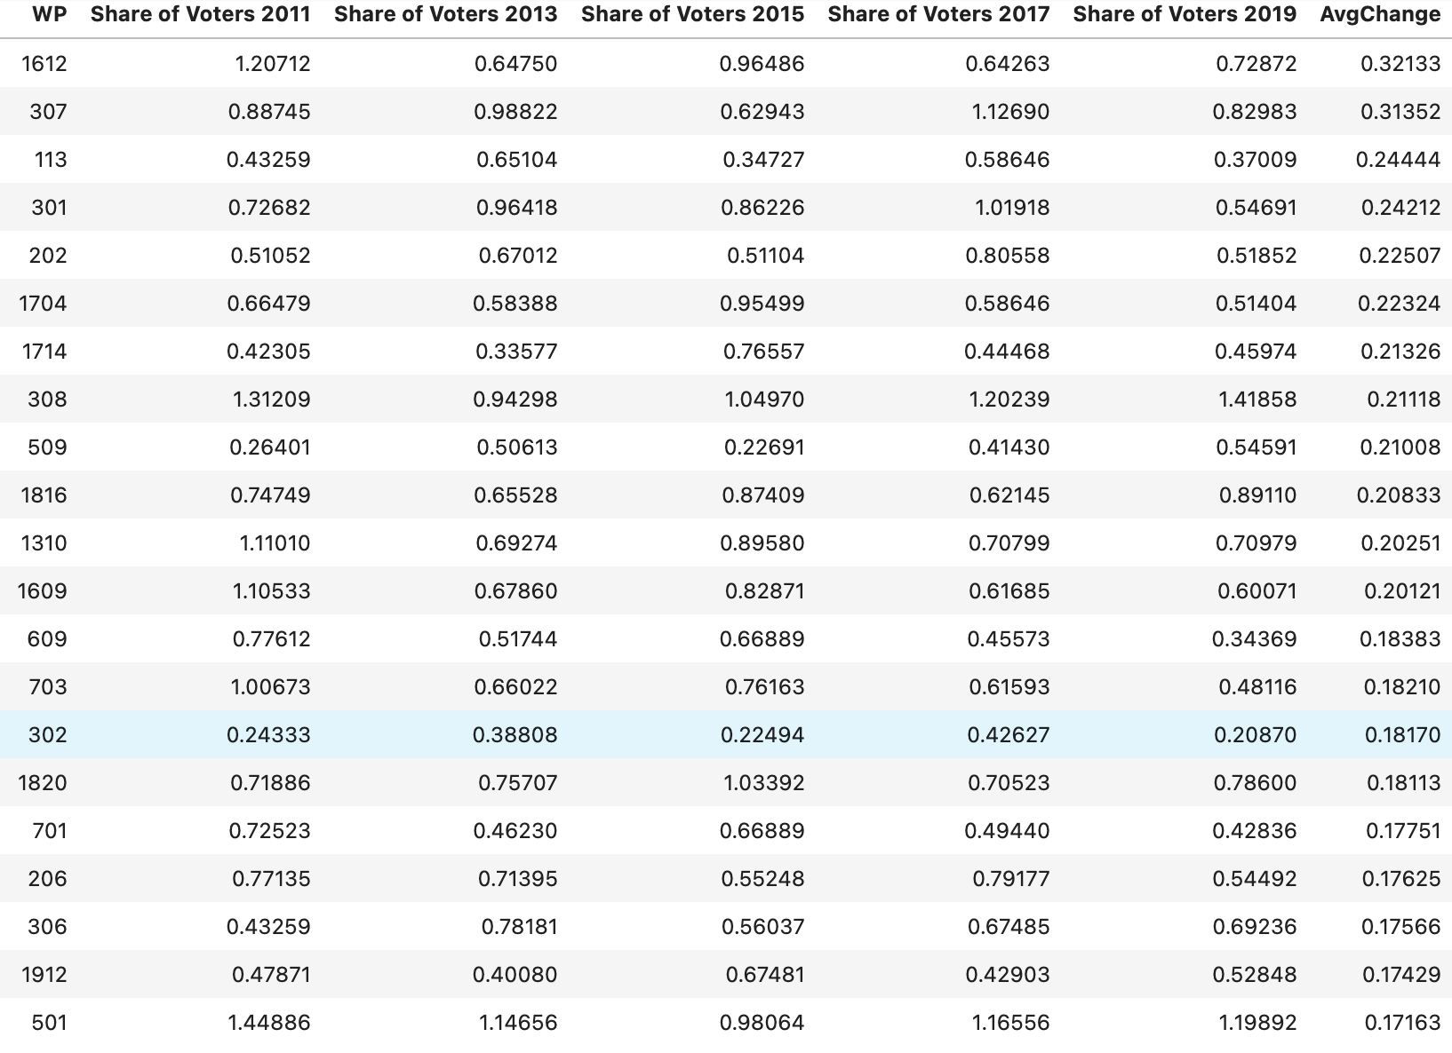

From the raw data, we can see that some of the top 20 precincts that experienced the greatest average change had a significant decrease in the share of voters (Example: WP 703), while others like WP 509 saw significant dips up and down across election year.

Visualizing, on a bar chart, the percent share of voters of each of these top 20 precincts:

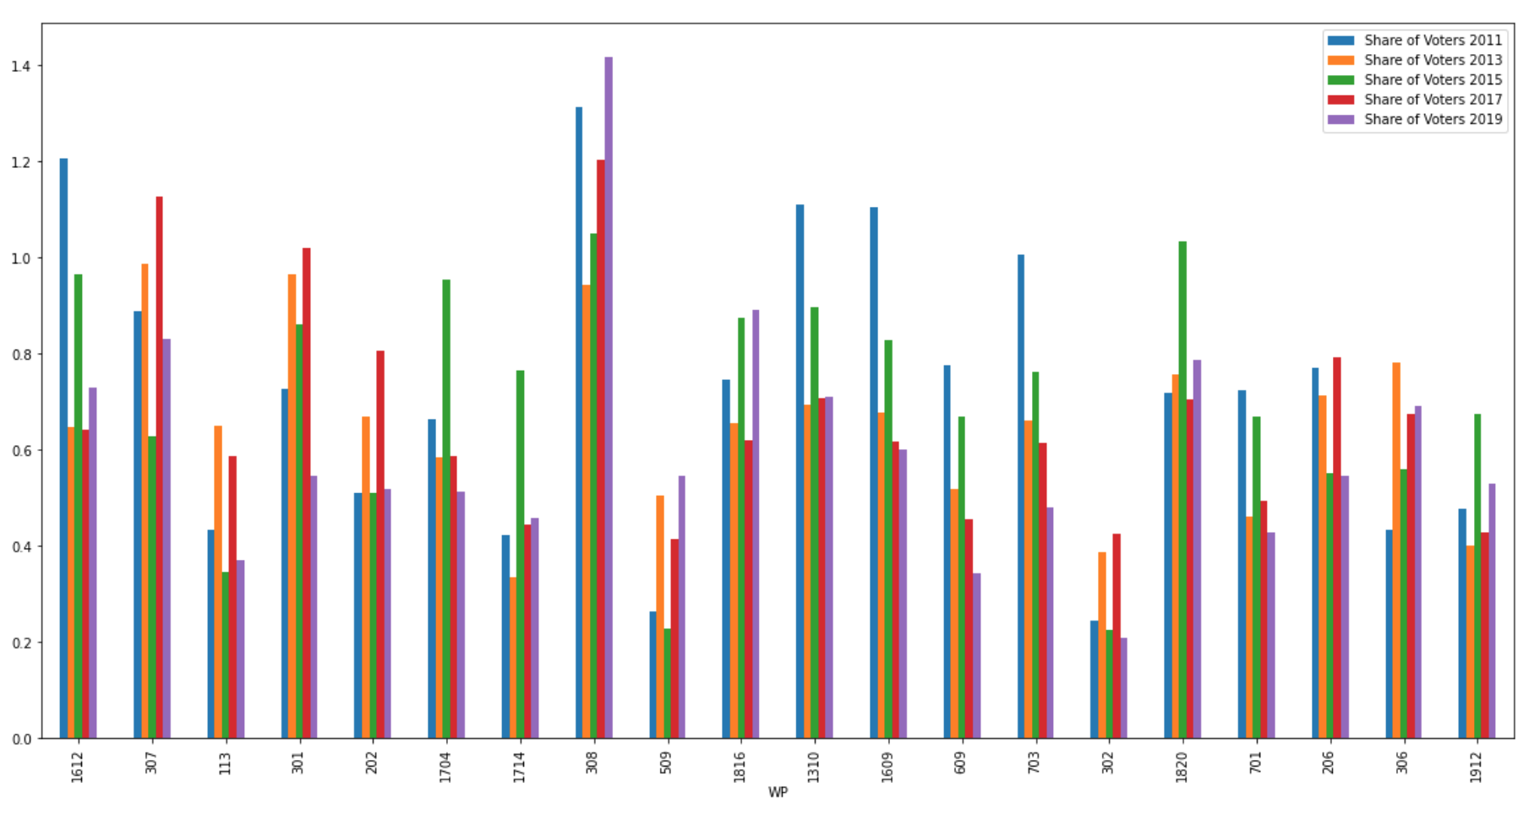

We can clearly see that the voter turnout has changed dramatically across each election in each of these precincts.

Listing the demographic breakdown of these precincts:

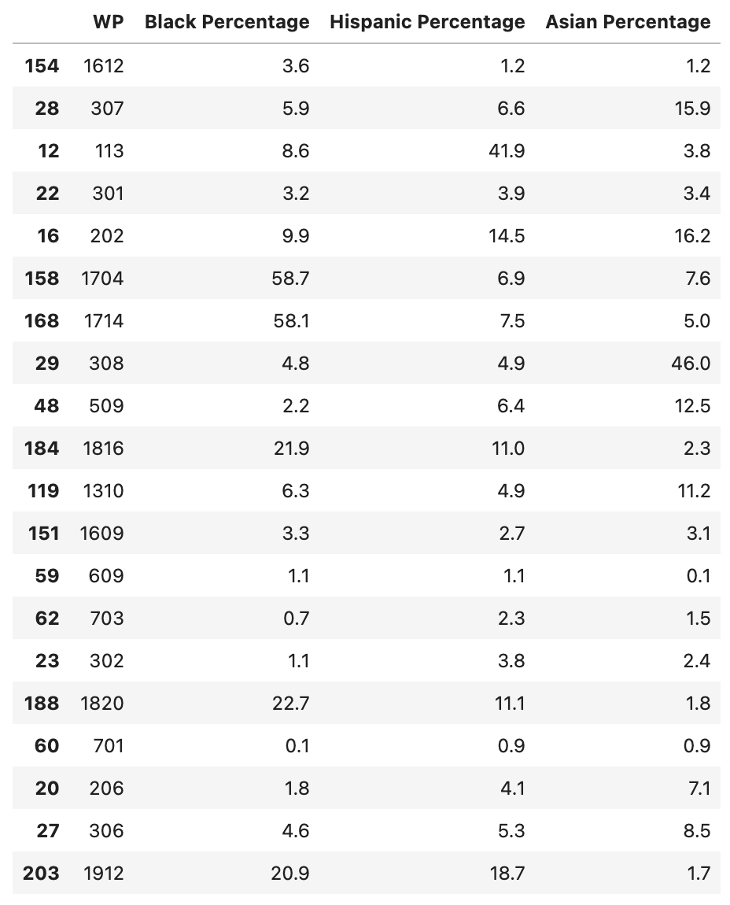

Now, visualizing the demographic breakdown of each of these precincts:

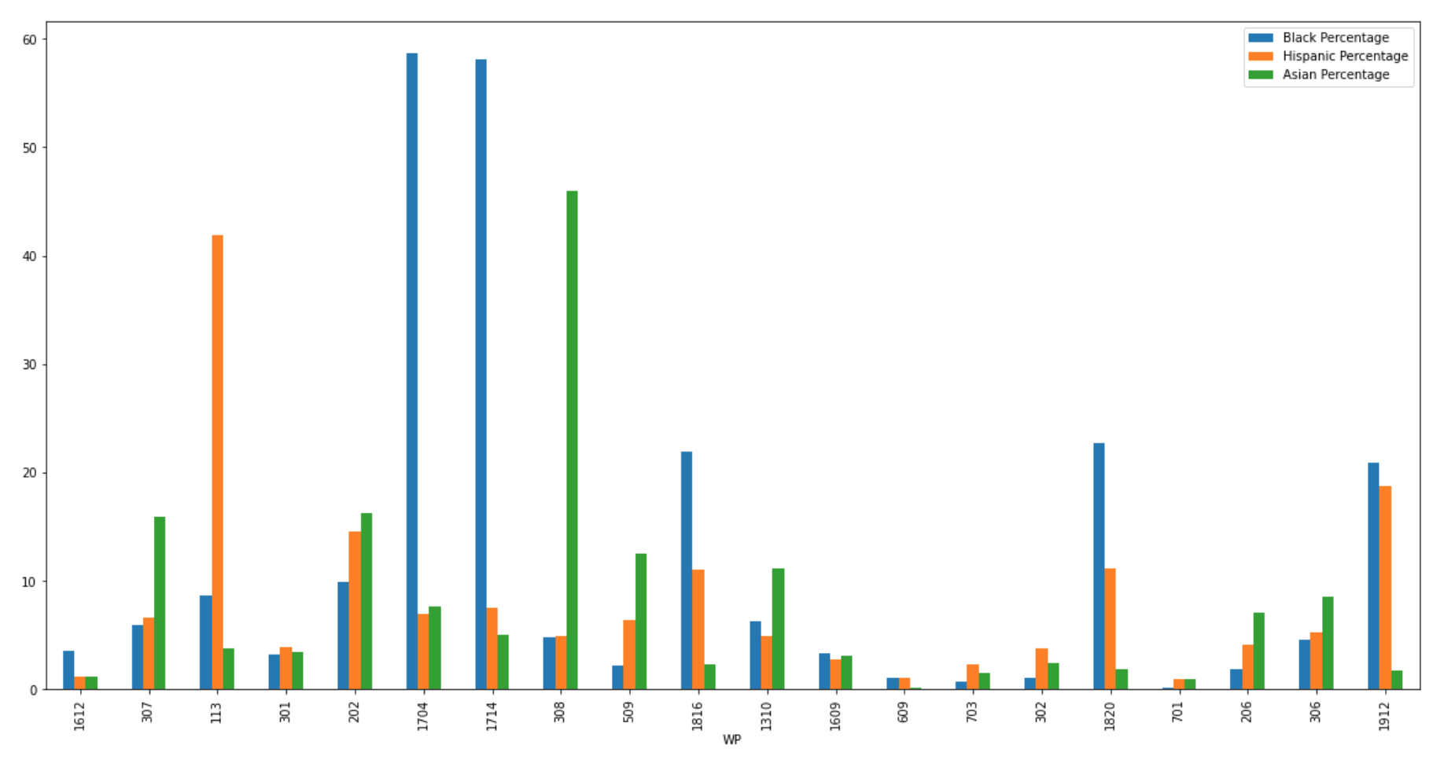

Here, we see that most of the precincts with the greatest change in share of voter turnout have a very small POC population. However, four precincts stand out amongst them: 113, 1704, 1714, and 308, all of which are majority POC precincts.

Visualizing on a map the geographic distribution of each of these precincts:

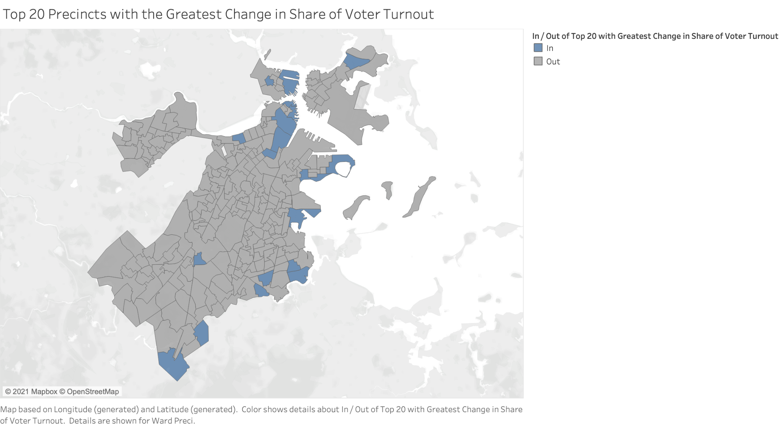

Here, we see that these precincts are a bit more scattered across Boston, but there is a slight concentration in an area of Dorchester and in Downtown Boston.

Viewing this information on a heat map:

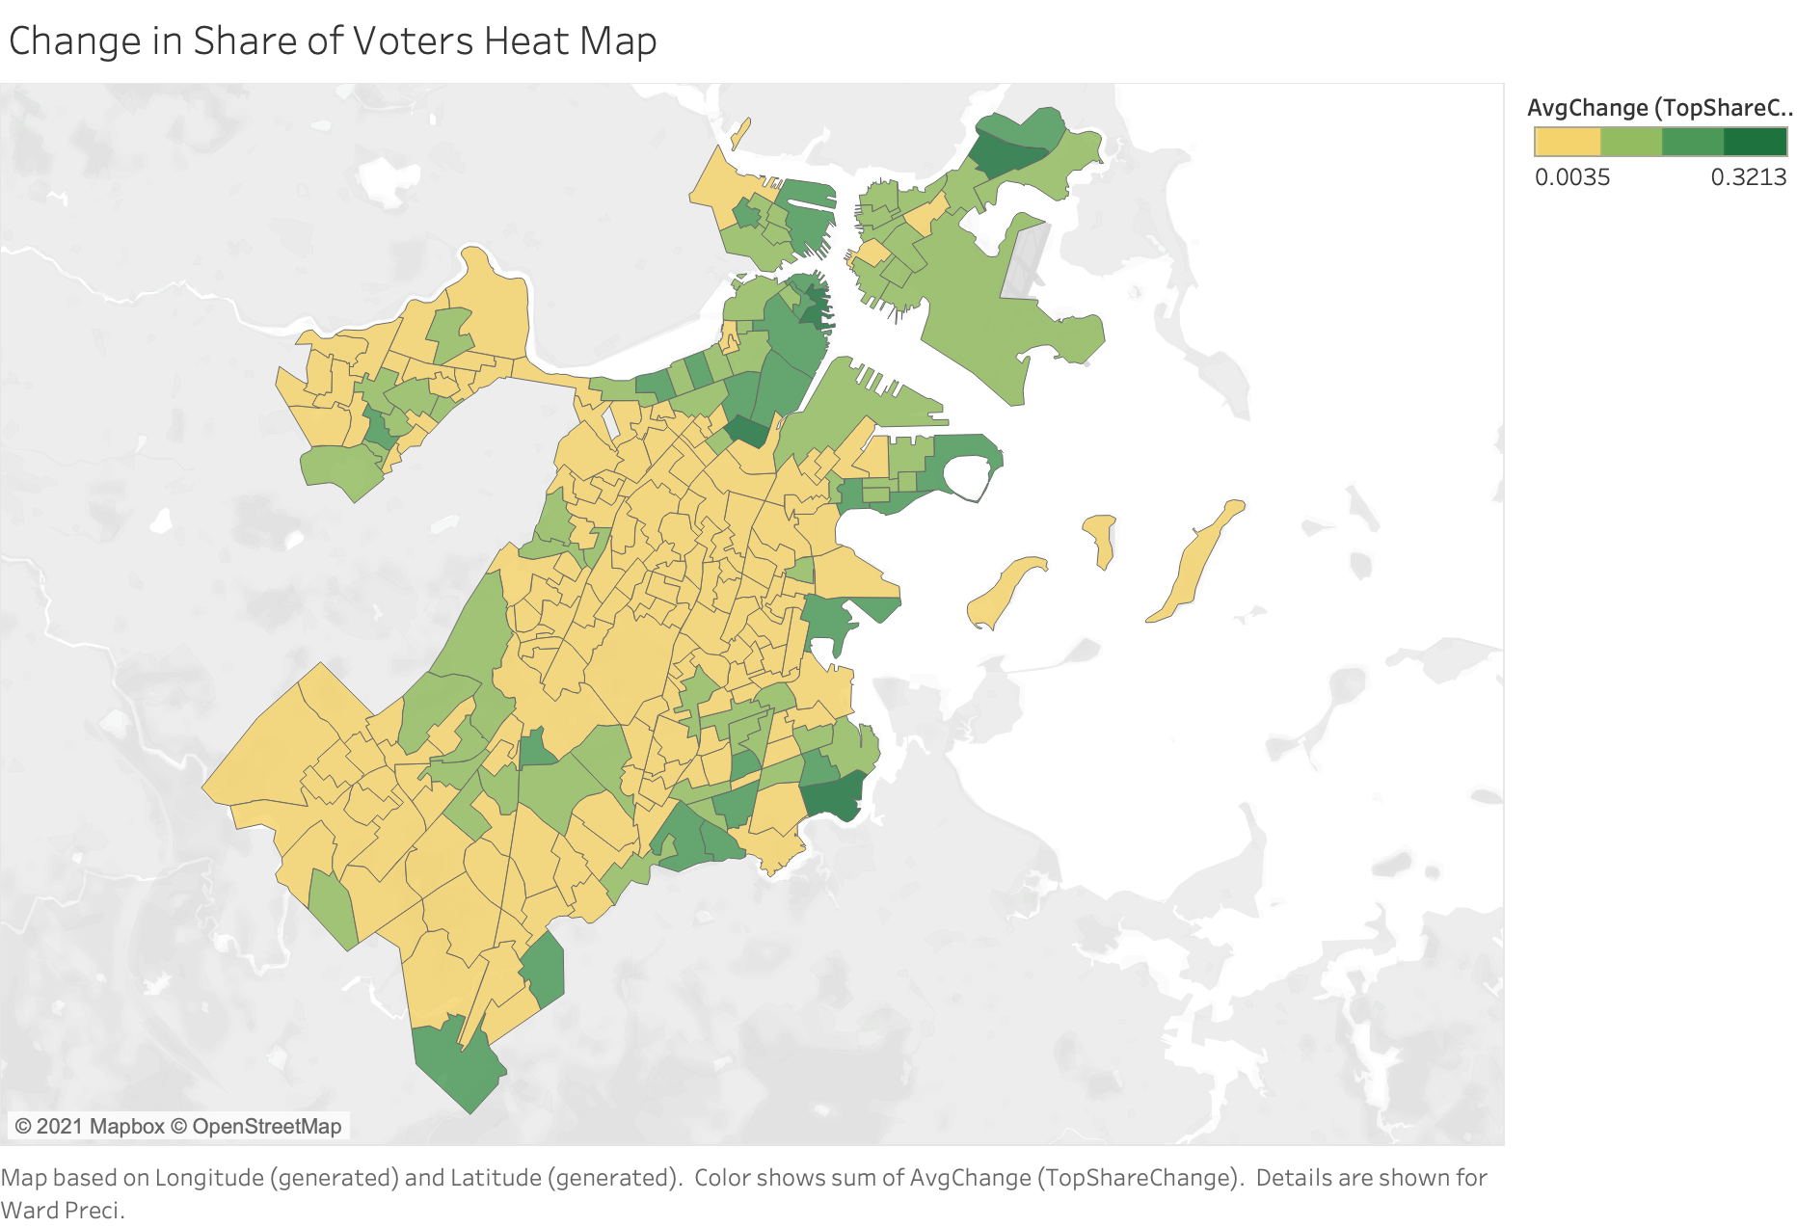

Here, the greens indicated those districts which have experienced a measurable change in share of total voter turnout. As we can observe, a lot of the intense green is concentrated in the Dorchester neighborhoods, as well as near downtown Boston, Seaport, and East Boston.

**Part 3: Visualizing the Change in Voter Turnout in Majority White/African American Precincts**

Analyzing City Council turnout by precinct, based on the majority race of that precinct, we find that in 2011, white population had much higher turnouts:

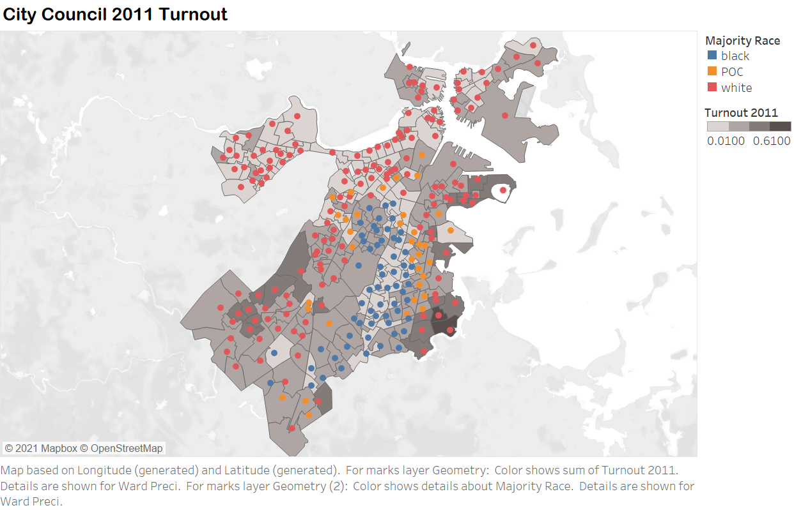

Similarly in 2013, but this time different precincts with majority of whites are having very high turnout rate:

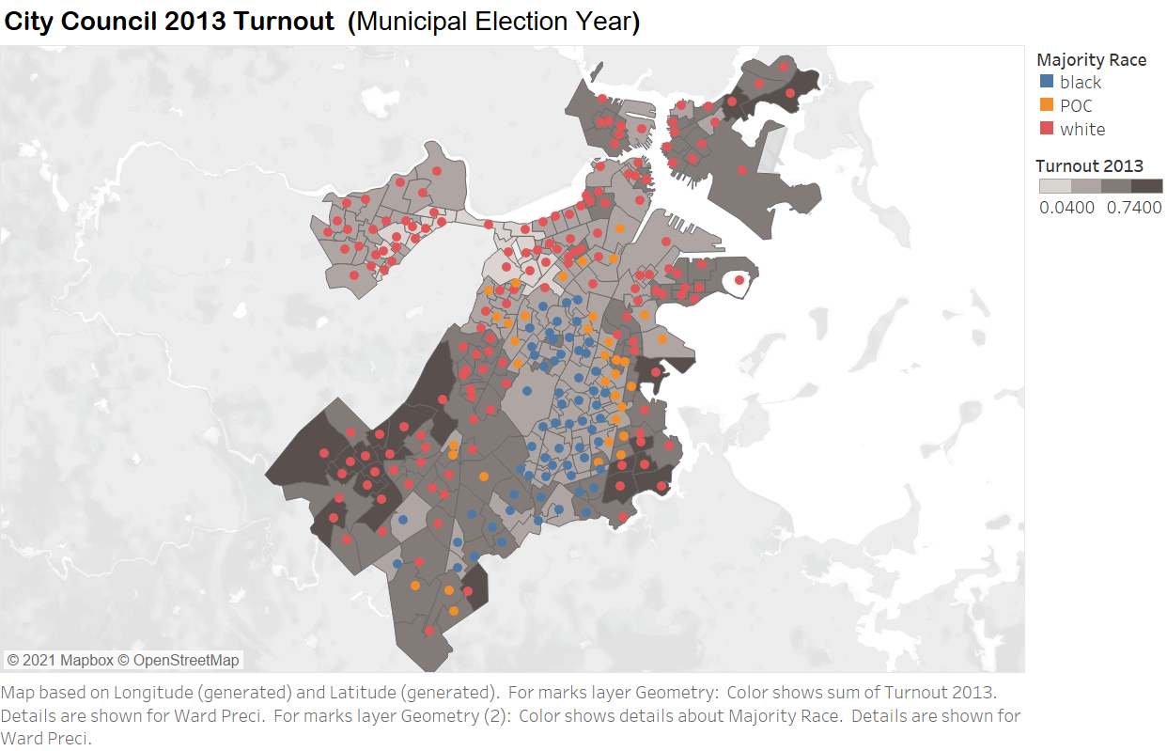

In 2015 however, we saw some majority black precincts show higher turnouts in relative terms, compared to white as you can see below:

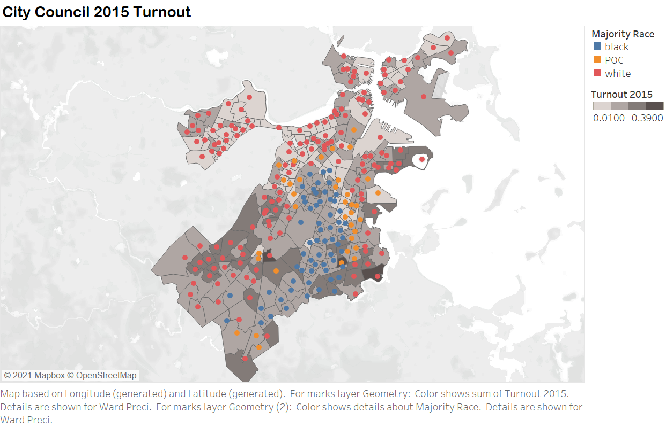

In 2017, we see different majority-black precincts with higher turnouts compared to previous years:

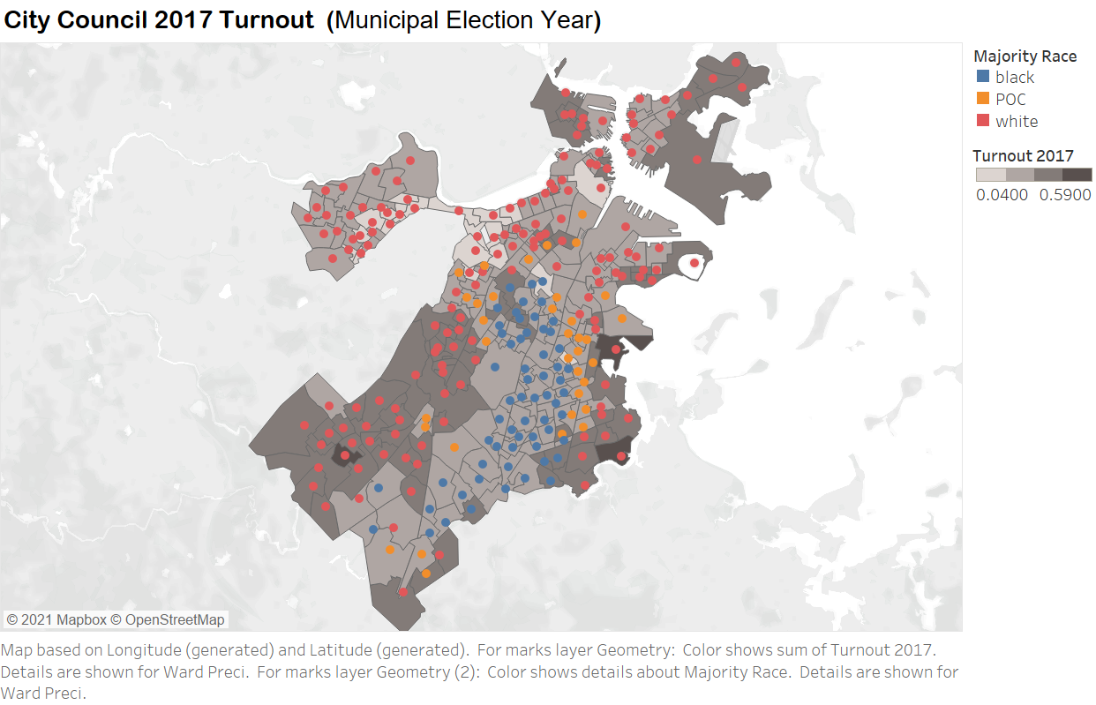

Finally, in 2019 overall turnout has decreased significantly compared to previous years:

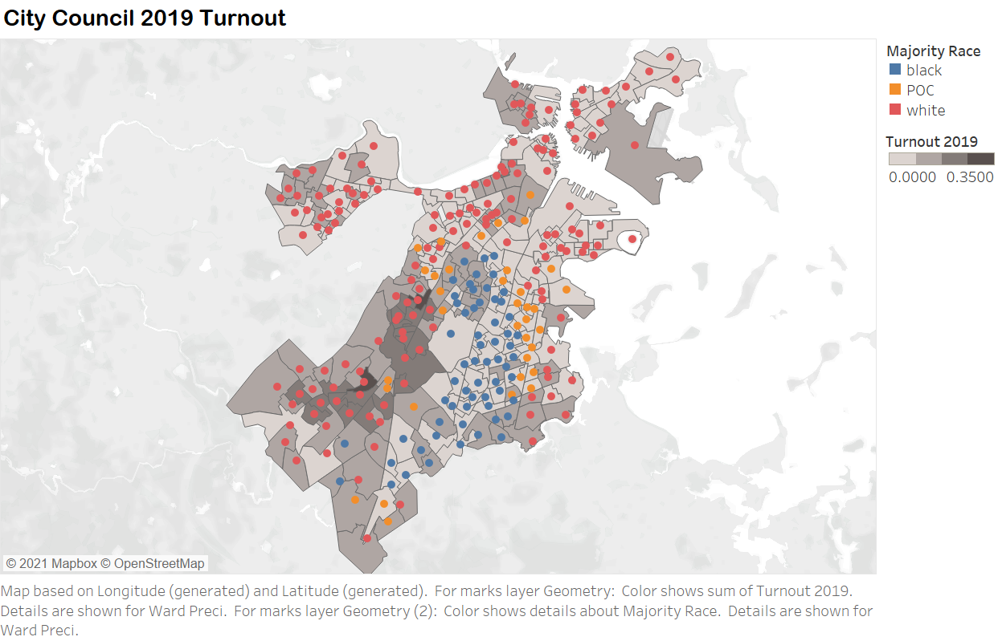

Overall, the turnouts fluctuate from year to year, and as we can see in 2011 the turnout rate ranged from 0.01-0.61, and in 2013 the range is 0.04-0.74, in 2015 the range is 0.01-0.39, in 2017 the range is 0.04-0.59, and finally in 2019 the range 0-0.35. So, clearly there is huge overall fluctuation in turnouts.

On relative terms, the turnout trend for majority black precincts tends to increase across the years, while for majority white precincts is volatile, pretty much reflecting overall fluctuations.

**Part 4: How has Michael F. Flaherty’s performance changed across districts with large white populations?**

In this section, we are going to find some relations between Michael F. Flaherty’s performance and districts with large white populations.

To begin, we made a graph of precincts with the most dramatic change of share of voters, and printed out the average turnout change for each year. (Flaherty is in the election from 2015 to 2019.)

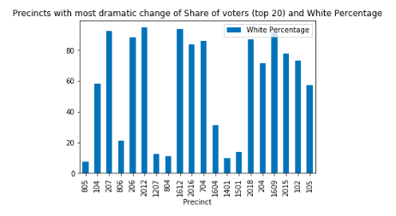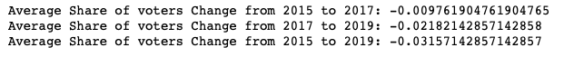

From the graph above, we can see that 13 over 20 precincts with the greatest average change in *share of voter turnout* over time have a large white population (above 50%). The average share of voters decreases each year since they are all negative.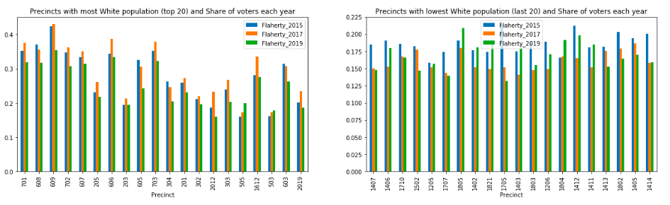

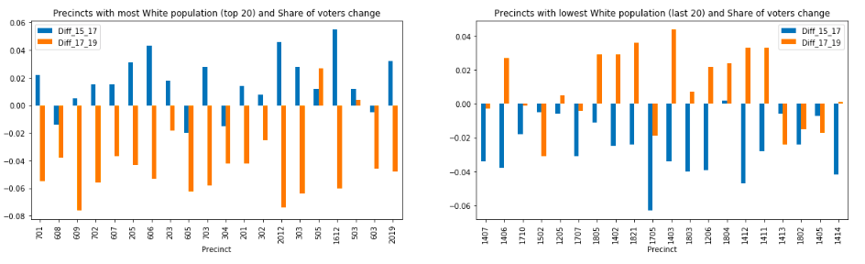

From the graphs above, we can see that the share of voter changes of 2015 to 2017 are mostly positive in precincts with most white population while are negative in precincts with lowest white population. We can know that, in precincts with most white populations, Flaherty was popular in 2017 but lost supporters in 2019.

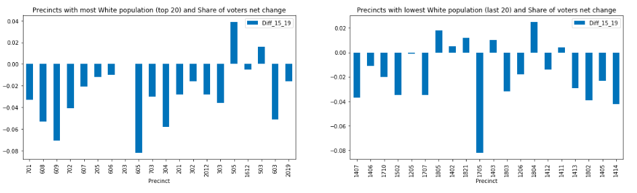

From the graph of the share of voters net change, we can see that most changes are negative, which corresponds to what we found before: Flaherty lost supporters in 2019 compared to 2015.

Visualizing it in actual map:

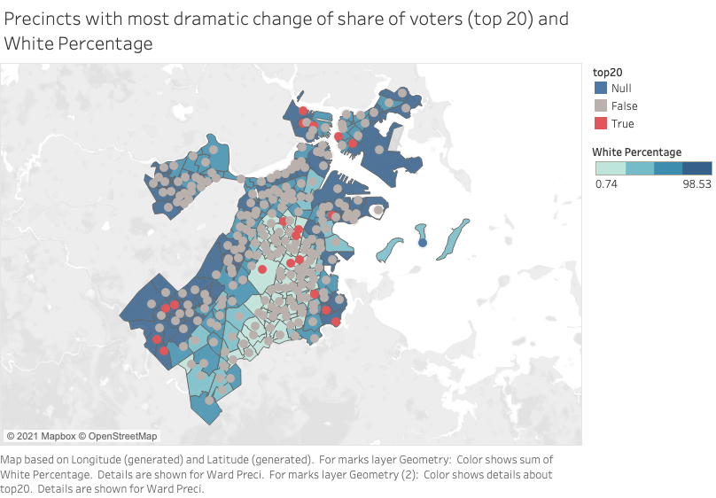

**Part 5: How has Michelle Wu’s performance changed over time?**

In this section, we will try to find the correlation between Michelle Wu’s most dramatic change of share of voters and different racial demographics.

To begin our analysis, we made a graph of precincts with the most dramatic change of share of voters across different races. We also printed out the average turnout change for each year. (Wu is in the election from 2013 to 2019.)

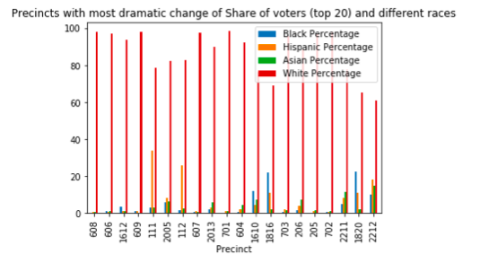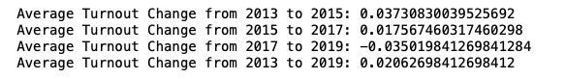

I found that, in general, she has more supporters in 2019 than in 2013. Only in 2019, she lost supporters compared to the last election (2017). In other years, she had a larger share of voters than last elections. All precincts with the most dramatic change of share of voters are with the most white population.

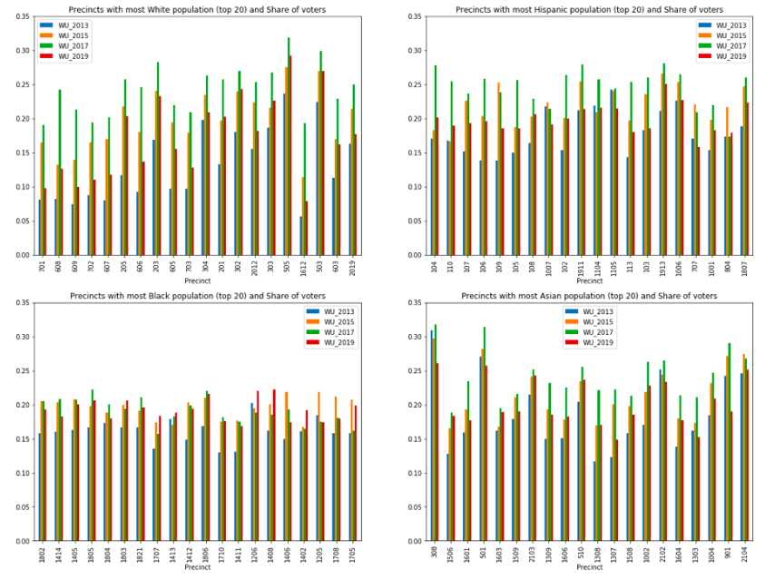

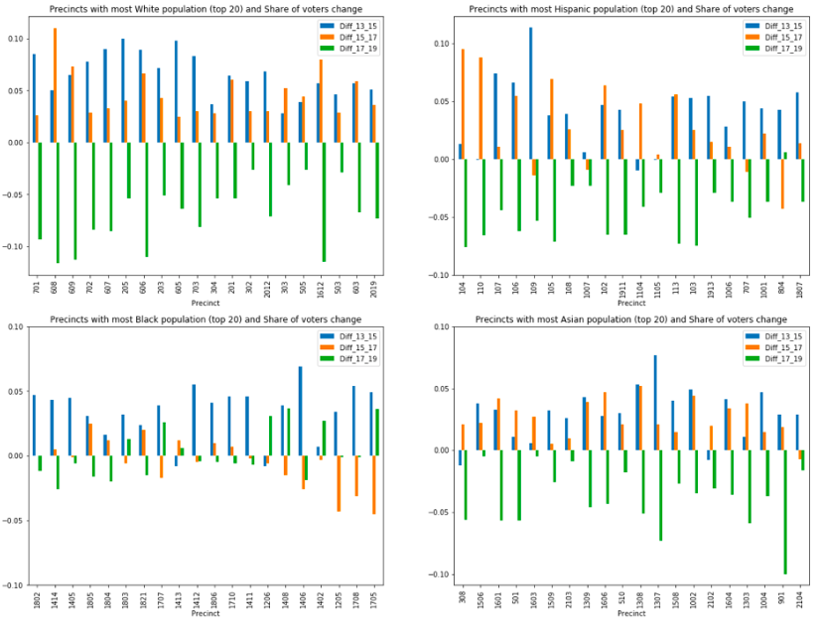

From the graphs, we can see that Wu has the most share of voters in 2017. In 2019 we can see a huge decrease of the share of voters in precincts with most white, hispanic and asian populations. The decrease is not obvious in precincts with most black populations. We can even see some increase.

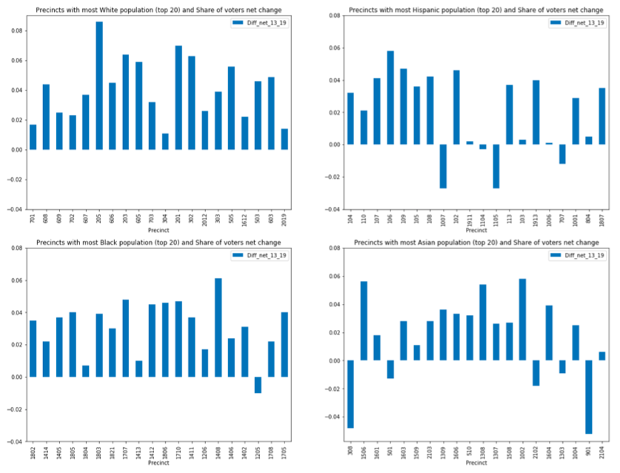

In general, Wu gained share of voters in 2019 compared to 2013, which corresponds to what we found before.

Visualizing it on an actual map:

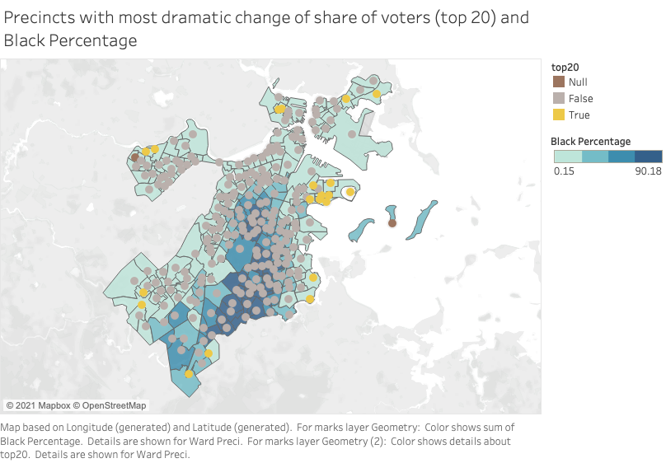

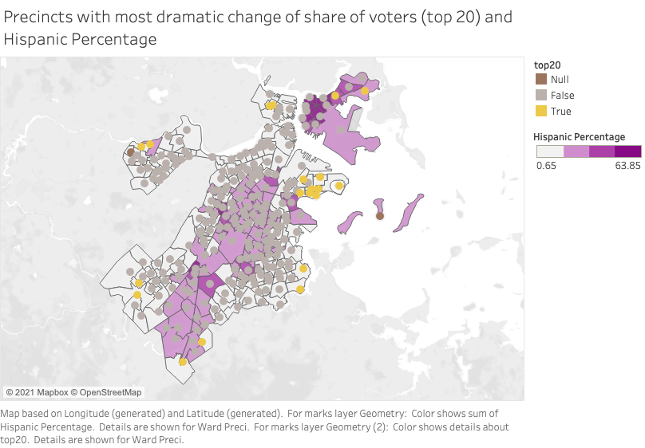

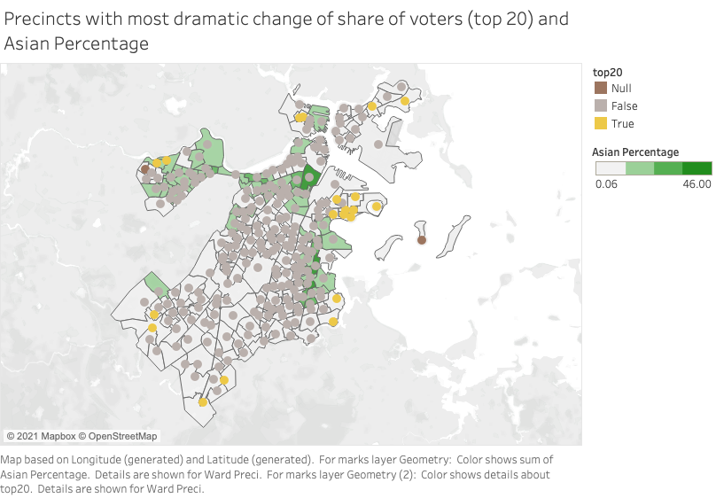

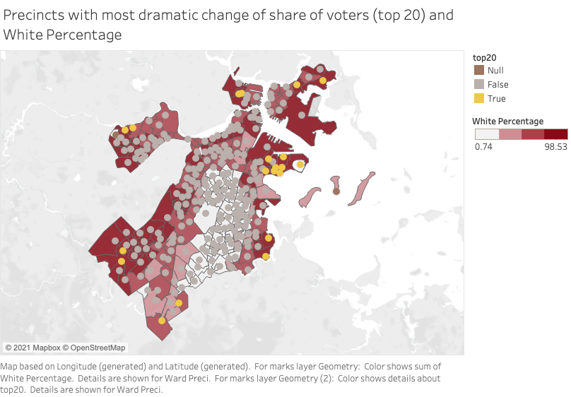

**Part 6: Changes in District 3 Specifically**

We break down our findings to focus specifically on District 3.

First, we look at all those areas, and compare turnout across the years in the following maps:

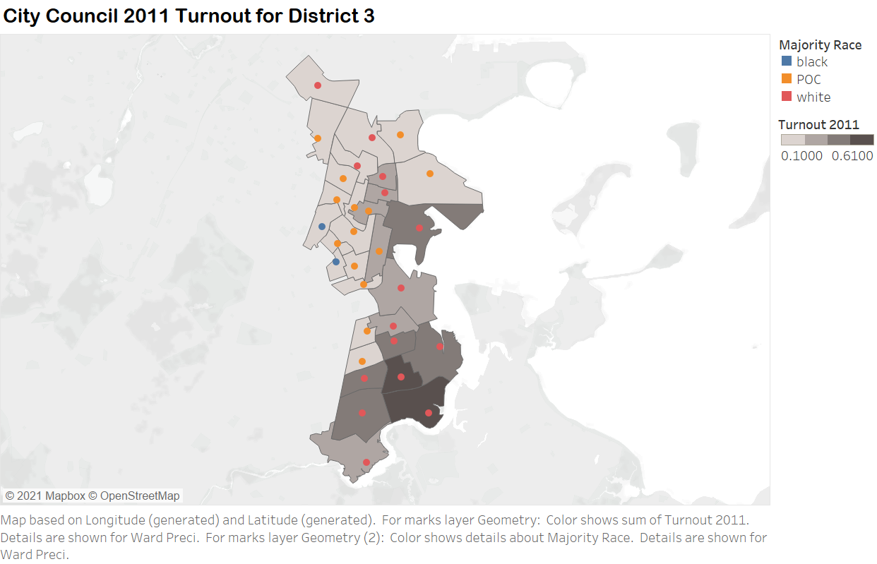

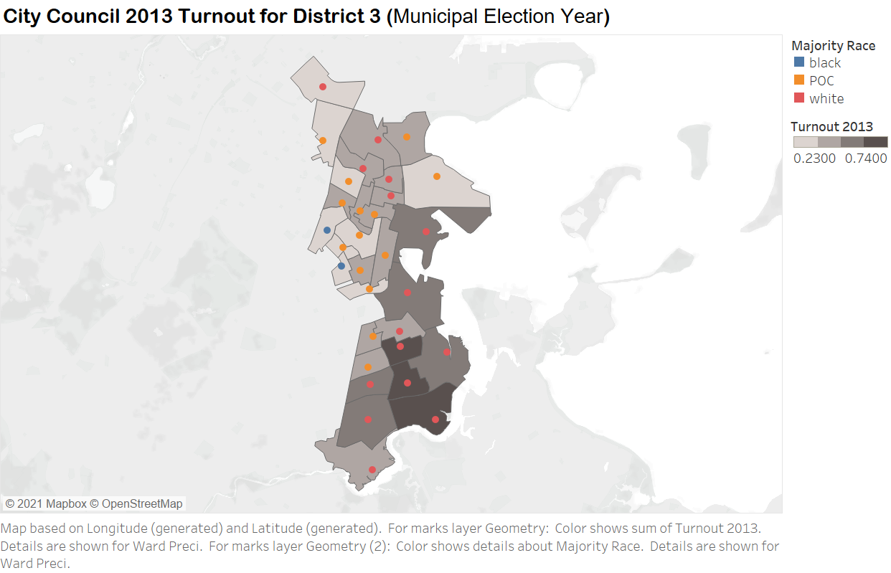

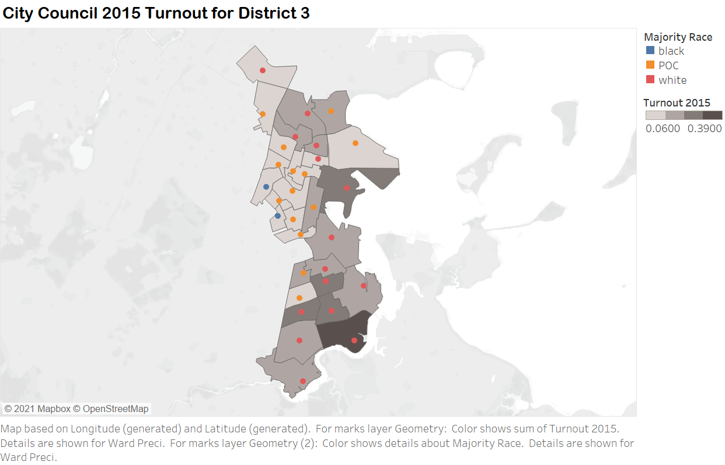

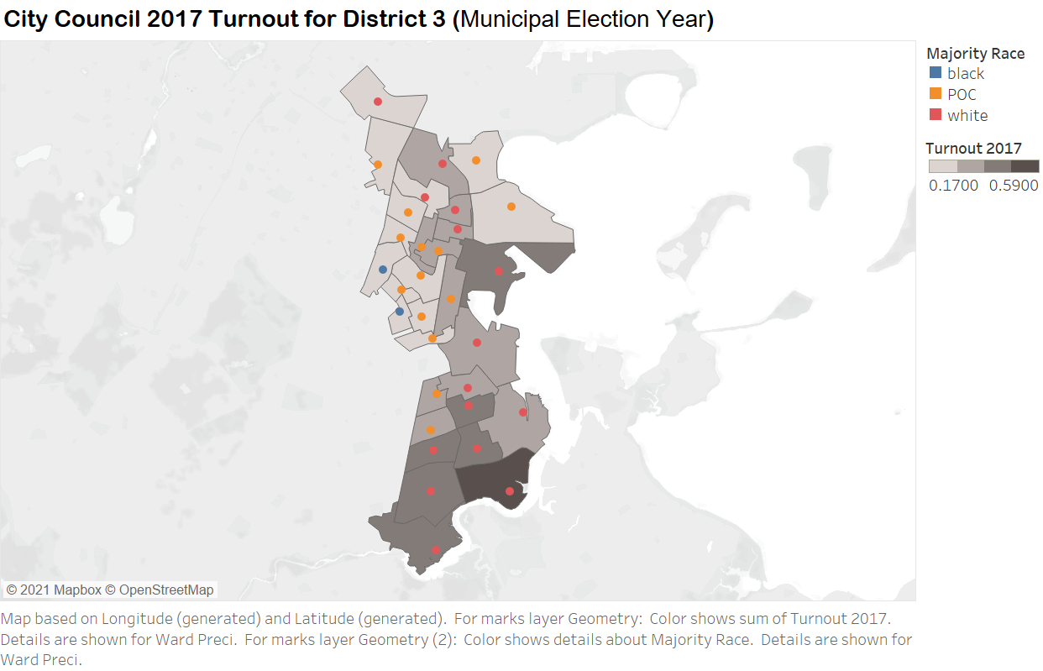

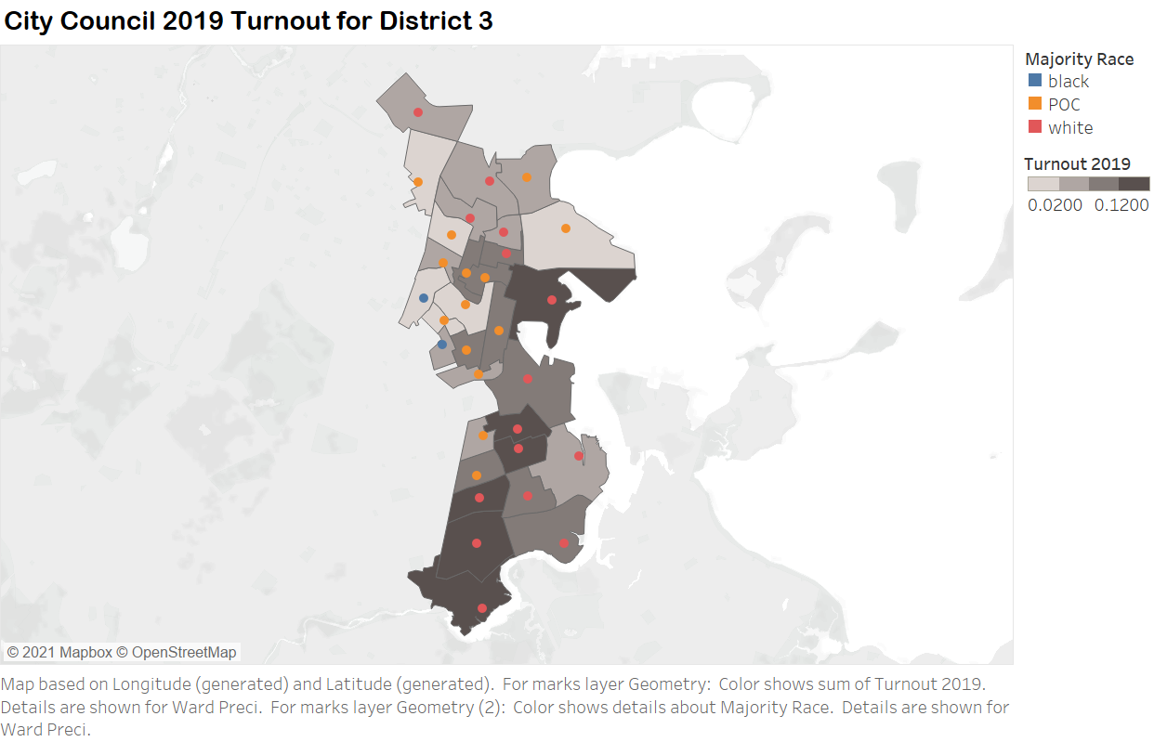

We find that for different years, different precincts have different turnouts, but the constant factor is the southern areas usually have much higher turnouts compared to northern ones on the above maps. On the racial side of things, precincts with majority blacks are recently improving their turnouts, as you can see on the left side of the maps.

Second, we find the top 10 precincts with the greatest volatility across city council election year in District 3:

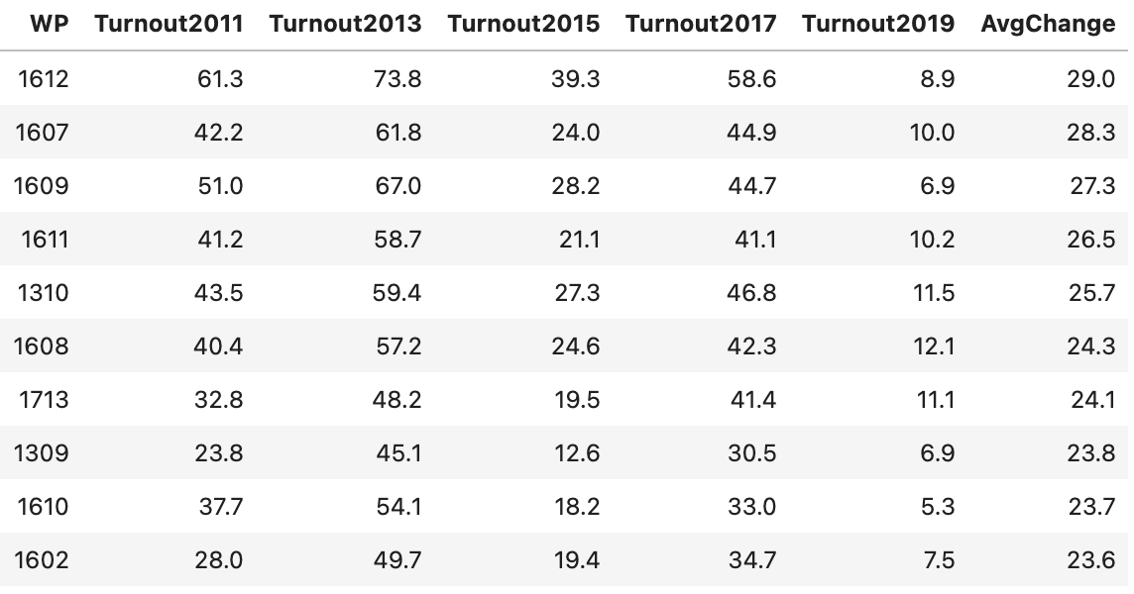

Visualizing the volatility:

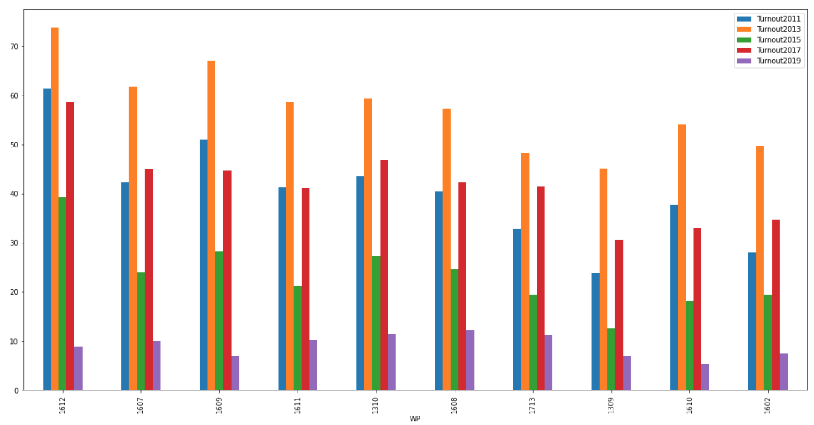

And finally, looking at the demographic breakdown of each of these top precincts:

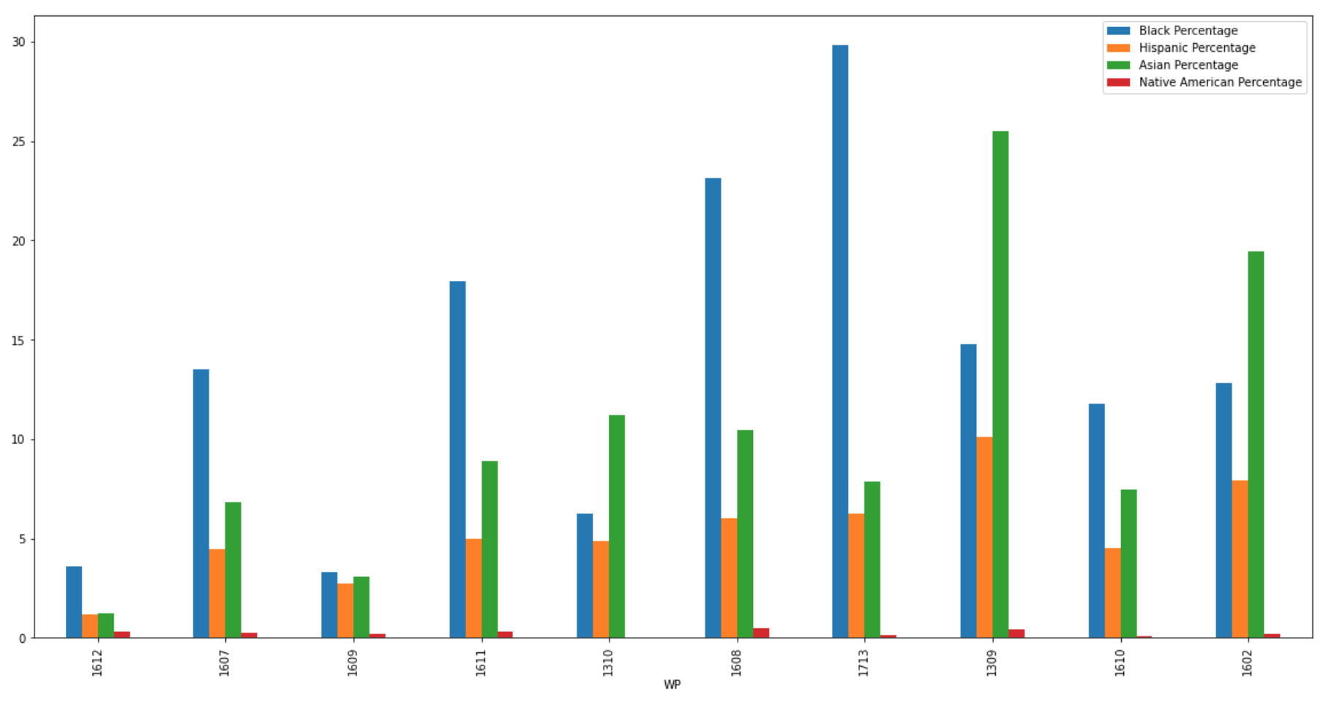

As we can see, about 3 of these precincts have a sizable black population (greater than 15%), while two have a sizable Asian population (greater than 15%). However, most have a majority white population, and the top most volatile district, 1612, has a very low POC population.

Visualizing this on a heat map of District 3:

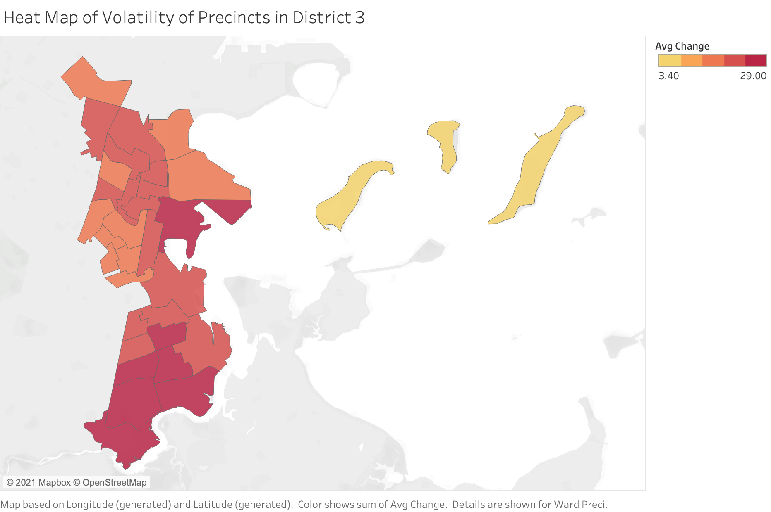

As we can see, those precincts with the greatest volatility across CC election years seem to be mostly concentrated in the southern part of District 3.

Now, for the same subset of District 3 wards, we determine the top 10 precincts with the greatest change in *share of voter turnout* from 2011 to 2019:

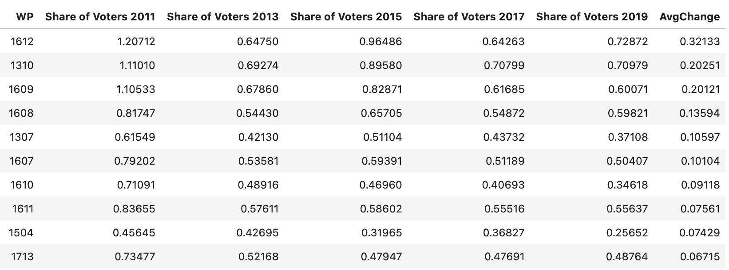

Again, here share of voters is [Ballots Cast in X Precinct]/[Total Ballots Cast in Boston] *100.

Visualizing how this share has changed over each year on a bar chart:

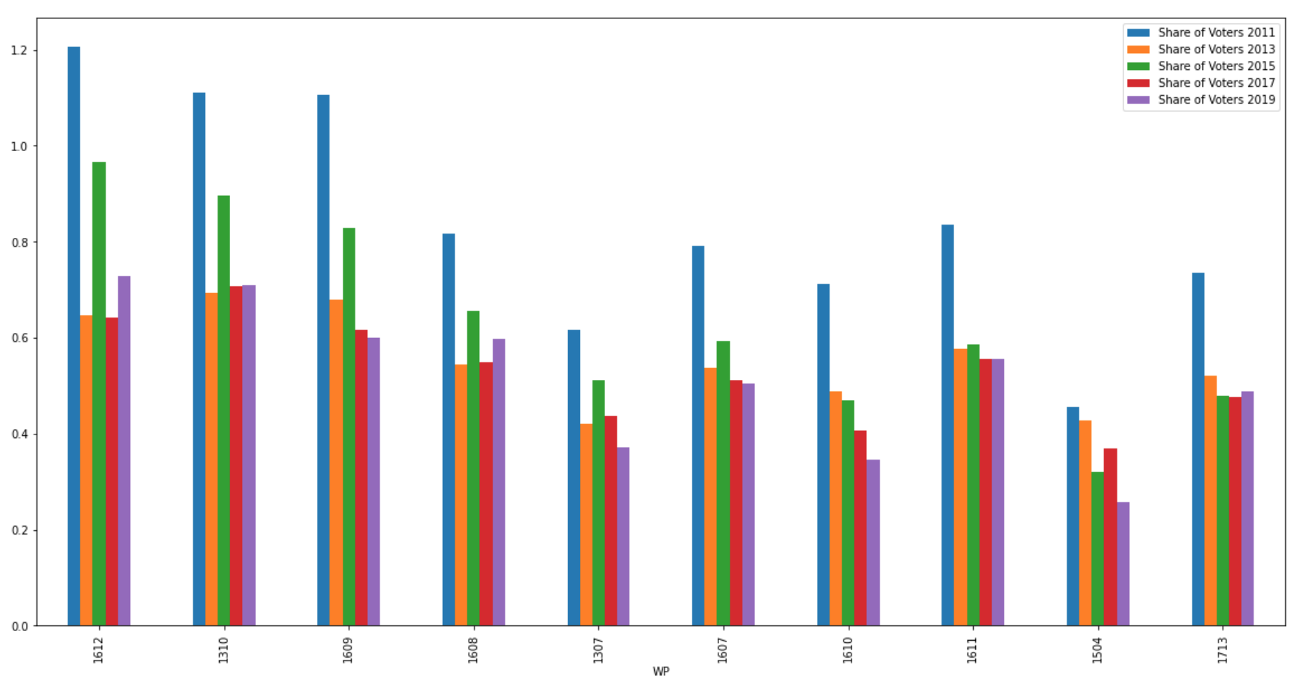

As we can see, the share of voters in Ward-Precinct 16-12 really fluctuates across the City Council election years, while Ward-Precinct 16-10’s share of total votes cast has really dropped off since 2011. 16-11, on the other hand, stays steady across most city council elections except 2011.

Now, for the demographic breakdown of each of these precincts:

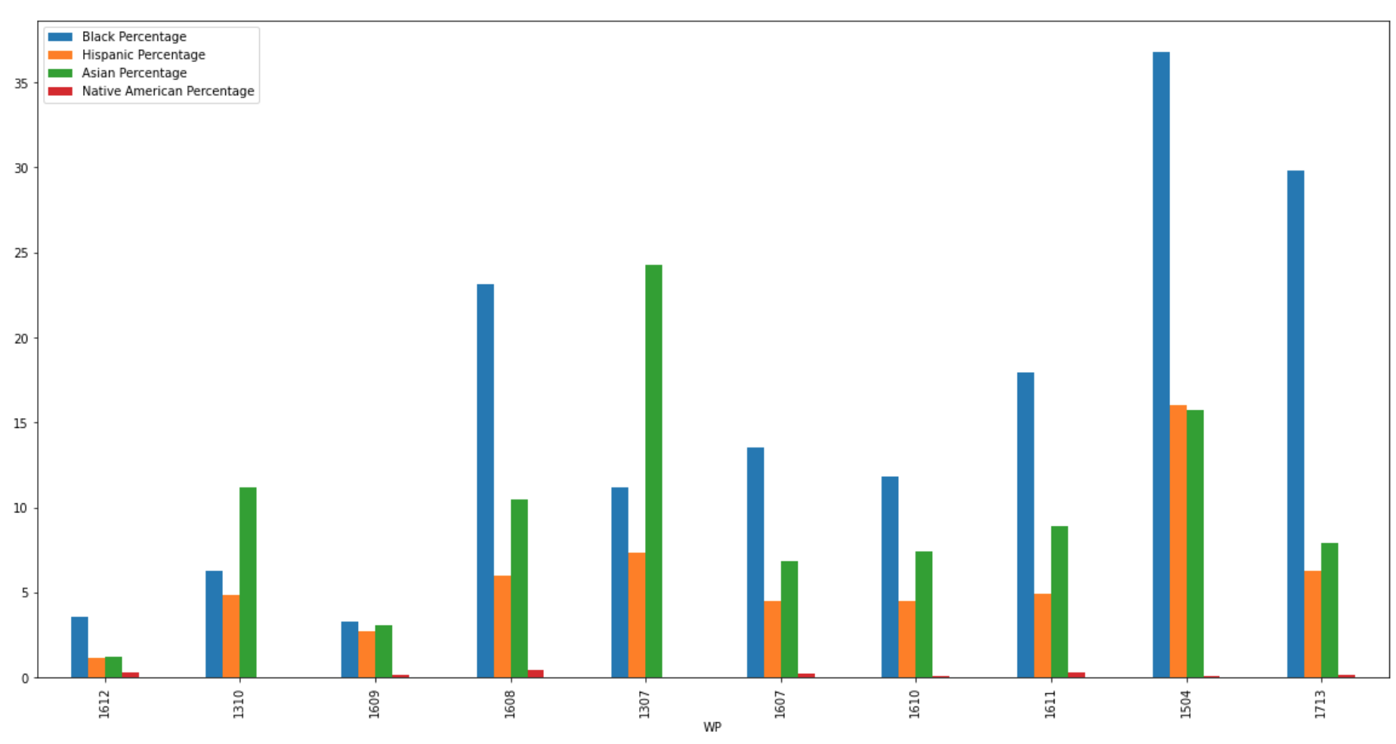

The demographics breakdown here indicates no clear pattern: some precincts have a very small POC population while some, like 1608 and 1307 are multiracial.

Visualizing this change in share of voter turnout on a heat map:

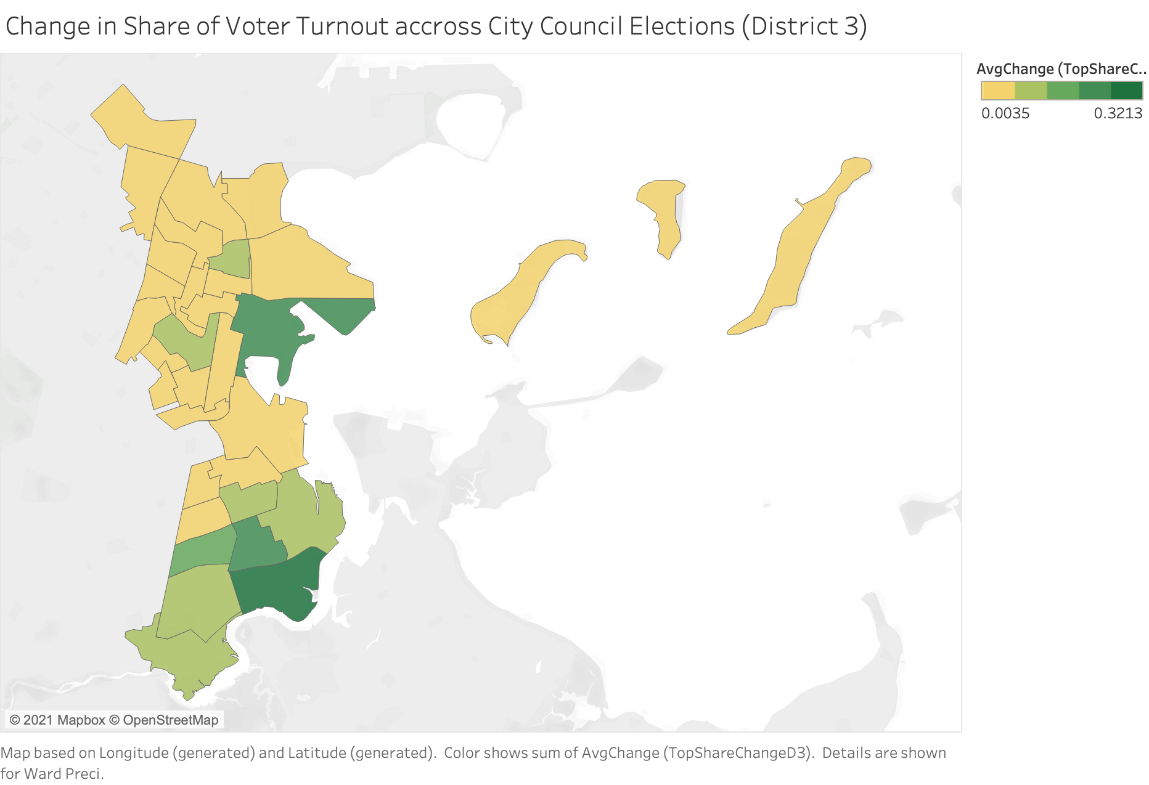

Similar to our previous findings, we find that those precincts with the greatest change in share of voter turnout tend to be concentrated in the southern part of District 3.

Now, we focus on how Michael F. Flaherty’s performance changed in precincts in District 3 with large white populations. 

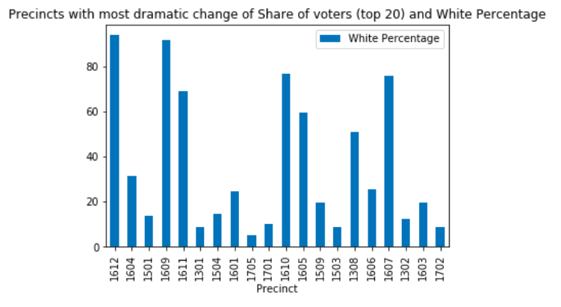

From the graph above, we can see that districts with the greatest average change in *share of voter turnout* over time do not have strong correlation with white percentage.

Lastly, we focus on how Michelle Wu’s performance changed in district 3 over time.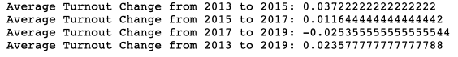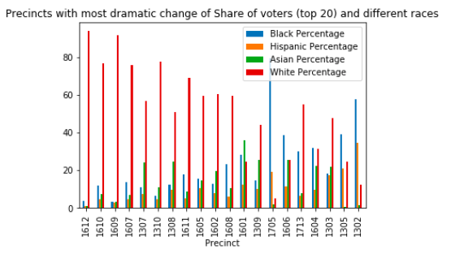

The turnout change trend in District 3 is the same as the overall trend. 16 out of 20 precincts with the most dramatic change of voter turnout are with the most white population. The rest 3 of the precincts with the most dramatic change of voter turnout are with the most black population. One is with the most asian population.

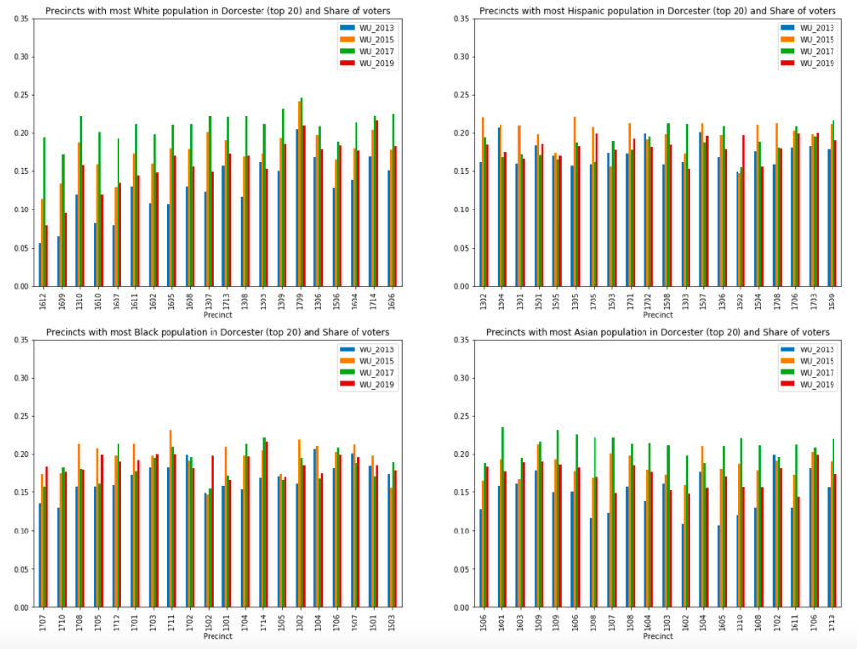

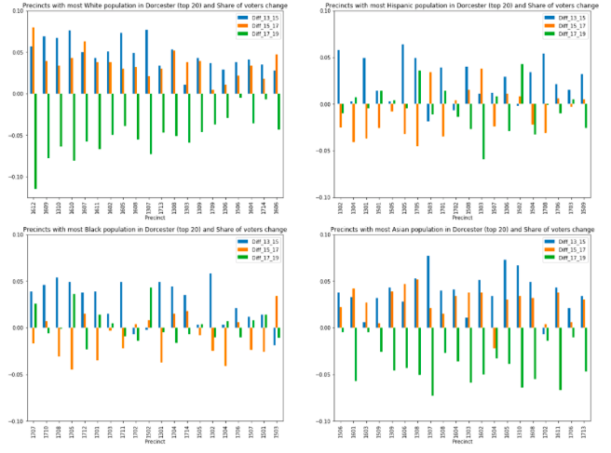

We can see that the decrease of share of voter turnout in 2019 is only obvious in precincts with most white and asian populations. In precincts with most hispanic and black population, we can see a decrease of share of voter turnout in 2017, but the decrease does not appear in precincts with most white and asian population.

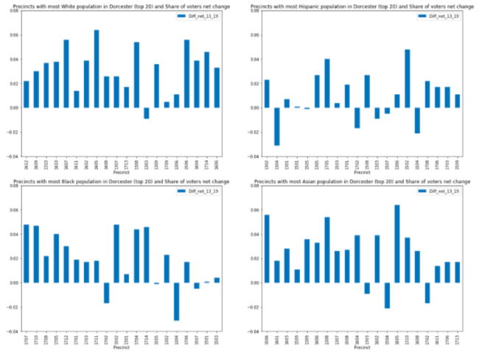

In general, Wu gained more supporters in 2019 compared to 2013, which is the same as the overall population.